Software Requirements Specification

Human Resource Management System.

**Supervisor:** Dr. Mohammad Taye.

**Prepared by:**

1) Fahed Khalil

2) Malik qawasmeh

3) Wesam da’abes

**Table of Contents:**

1 Introduction ....................................................................................................................................... 3

1.1 Purpose ....................................................................................................................................... 3

1.2 Scope ..................................................................................................................................... 3

1.3 Definitions,acronyms and abbreviations .................................................................................................................................. 4

1.4 References ................................................................................................................................... 4

1.5 Overview .................................................................................................................................... 4

2 Overall Description ........................................................................................................................... 4

2.1 Product Perspective .................................................................................................................... 9

2.2 Product Functions ...................................................................................................................... 9

2.3 User Characteristics

.................................................................................................................... 5

2.1 Constraints

………………. ............................................................................. 9

2.2 Assumptions and dependencies

……………………………………….. ………………………………. 10

2.3 Apportioning of requirements

………………………………… …………………………………... 10

2.4 Functional Requirements

………………………………………………………………..11

2.5 Non-Functional Requirements:

……………………………………..…………………12

3. Specific requirements ................................................................................................................................ 7

3.1.1 User interfaces ............................................................................................................................. 7

3.1.2 Hardware interfaces ..................................................................................................................... 8

3.1.3 Software interfaces ....................................................................................................................... 8

3.1.4 Communications interfaces .......................................................................................................... 9

**1 Introduction:**

This document is a Software Requirement Specification (SRS) for the Human Resources Management System (HRMS) Project. We will give a complete description for overview and list the requirements which meet the needs of the company.

**1.1 Purpose:**

The purpose of this document is to give a detailed description of the requirements of HR Management System (HRMS). This document is primarily intended to be proposed to overcome the problems faced in the practicing of manual system, reduce the hardships faced by the existing system and to particular need of the company to carry out its operations in a smooth and effective manner.

**1.2 Scope:**

HR Management System is a website used to complete some simple transactions using the Internet instead of the paper-based system. The site provides the following services: 1) Request leave or submit a complaint to the manager 2) The daily work schedule in addition to the number of additional hours desired by the employee 3) Inquire about the salary and its value this month 4) Each employee can register with the employee's identification number and password.

This website is beneficial for companies in maintaining employee record. Salary calculation for each employee and also focus on attendance of each employee and the number of leaves taken per month / year. There is also the possibility to check the salary report at any time so as not to lead to any miscalculation.

**1.3 Definitions, acronyms and abbreviations:**

|  |  |  |
| --- | --- | --- |
| **1** | SRS | Software Requirements Specification |
| **2** | EIN | Employee Identification Number |
| **3** | HRMS | Human Resource Management System |
| **4** | LMS | Leave Management System |
| **5** | OP | Overtime Pay |
| **6** | Admin / Administrator | Administrator who is given specific permission for managing and  controlling the system |

**1.4 References**

**IEEE Citation Style Guide**

**World Wide Web**

A.projects*. “Title.” Web student portal for the it and management: www.freeprojectz.com, Nov.7,2014* [March.10,3,2021].

**Lecture**

M. Tayee. Dr. final project, Topic: “discussing.” ICT 224, Faculty of IT, University of Philadelphia, Jordan, Amman, April. 31, 2021.

**E-mail**

W.daabes “new message ,done?wesamdaabes98@gmail.com ”. (April.3,2021).

**1.5 Overview:**

The remainder of this document includes three chapters and appendixes. The second one provides an overview of the system functionality and system interaction with other systems. This chapter also introduces different types of stakeholders and their interaction with the system. Further, the chapter also mentions the system constraints and assumptions about the product.

The third chapter provides the requirements specification in detailed terms and a description of the different system interfaces. Different specification techniques are used in order to specify the requirements more precisely for different audiences.

The fourth chapter deals with the prioritization of the requirements. It includes a motivation for the chosen prioritization methods and discusses why other alternatives were not chosen. The Appendixes in the end of the document include the all results of the requirement prioritization and a release plan based on them.

**2. Overall description:**

This section will give an overview of the whole system. The system will be explained in its context to show how the system interacts with other systems and introduce the basic functionality of it. It will also describe what type of stakeholders that will use the system and what functionality is available for each type.

At last, the constraints and assumptions for the system will be presented.

This section does not state specific requirements. Instead it provides a back ground for those requirements, which are defined in section 3, and makes them easier to understand.

**2.3 User characteristics:**

There are three types of users that interact with HRMS: Employees, Managing Director/Admin, Company Owners and IT Developer. Each of these three types of users has different use of the system so each of them has their own requirements.

Employees: The website provides the following services for employees: 1) Request leave or submit a complaint/report to the manager 2) The daily work schedule in addition to the number of additional hours desired by the employee 3) Inquire about the salary and its value with OP working this month 4) Each employee can register with the EIN and password.

Managing Director/Admin: Manager is also an employee and his interests in the website will be: Salary, Working hours, Job security. But he has a special validity which is managing vacation request and reports. Which is mean he can accept or reject the vacation request or reports.

Company Owners: The only thing that company owners are interested in the website is profit and business operations to run smoothly.

**System Design:**

1. **Class diagram:** 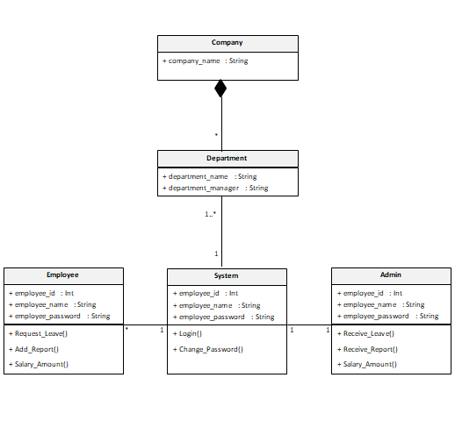
2. **Use case:**

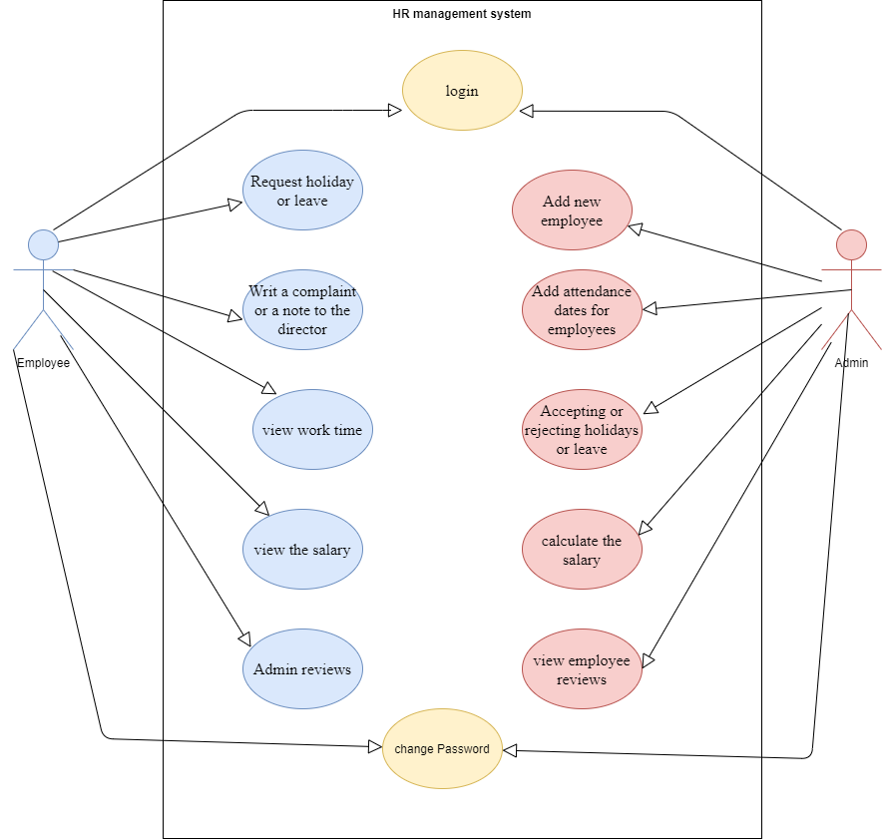

**Software system attributes:**

The Website can flexibly operate under any kind of organization structure and employee

hierarchy. From the point of view of the organization's administrators, the Website is quite easy to deploy, operate and maintain.

The system is also able to audit each and every user action that results in database access (read or write). Examples include: add/edit administrative data, user login, query, distribution, and so forth.

Besides, it can be ported to different platforms with several available customizations and plug-ins.

The system is capable of scalability to increasing numbers of users, transactions, etc.

Despite the flexibility of the system, the website is designed and customized for companies.

**Product perspective:**

This system consists of a website. The website will be used to facilitate the process of information exchange between the two parties of the manager and the employee and the completion of transactions for the employees.

The website will need to connect to the internet from any smart device in order to be able to use it. The website will provide the employee with jobs like (vacations - working hours - employee or manager notes within work - and salary inquiries)

The functions provided by the website will be included so that the user can use the functions in the application smoothly Since this is a data-driven product, it will need somewhere to store the data. Therefore, a database will be used. The website will communicate with the database.

**Product functions:**

Completing some online transactions, the most important of which are (requesting leave, submitting a complaint, sending notes to the manager or receiving them, knowing the employee's daily work schedule or from or calculating the employee's salary.

**Constraints:**

There are two types of users interacting with the system: staff and administrator. Each of these two types of users has different system permissions

Employees of the website can only submit their transactions or comments, and the managers of the website can approve the employee’s transactions, reject or respond to their comments.

**Assumptions and dependencies:**

One of the assumptions about the product is that it will always be used on the website accessed from any smart device. For example, users may have customized it with other websites, there may be scenarios where the website does not function as intended or even at all.

**Apportioning of requirements:**

In the case that the project is delayed, there are some requirements that could be transferred to the next version of the website.

**Functional requirements:**

This section includes the requirements that specify all the main actions of the software system.

**Functional Requirement 1**

**ID**: FR1

**TITLE**: Use of the Website

**DESC**: The user must be able to access the website from any smart device. The website must be free to access

**RAT**: for the user to use the website

**DEP**: None

**Functional Requirement 2**

**ID:** FR2

**TITLE:** log in

**DESC:** The user must be able to enter the site and choose the employee or manager **RAT**: for the user to use the website

**DEP:** FR1.

**Functional Requirement 3**

**ID**: FR3

**TITLE:** Request a service

**DESC:** The employee must be able to request a service he wants to provide to him by sharing and waiting for a response from the manager.

**RAT**: for the user to request a required service.

**Functional Requirement 4**

**ID**: FR4

**TITLE:** Search

**DESC:** The manager must be able to search for a specific employee by name.

**RAT:** for the manager to search for a specific employee

DEP: FR2.

**ID:** FR21

**TITLE** **:**Website - Profile Page

**DESC:** On the website, the user must have a profile page. On the profile page, the user can edit their information, which includes password, email address and phone number. The user must also be able to choose which language to understand. The different language options are Arabic and English.

**RAT:** in order for a user to have a profile page on the website. DEP: FR1

**Non-Functional Requirements:**

**ID: QR1**

**TITLE:** Usability

DESC: website should be easy to learn, support speed performance, low error rate and user attitude.

**RAT:** In order for a user to use the system easily

**DEP:** None

**Privacy**

**ID: QR2**

**Title:** Privacy

**DESC:** The website should support information privacy for all users and their record will be private and stored in the servers and will not be available to anyone without the user's permission.

**RAT:** so that the user can use the system without any concerns about his data.

**DEP:** None

3.1.1User interfaces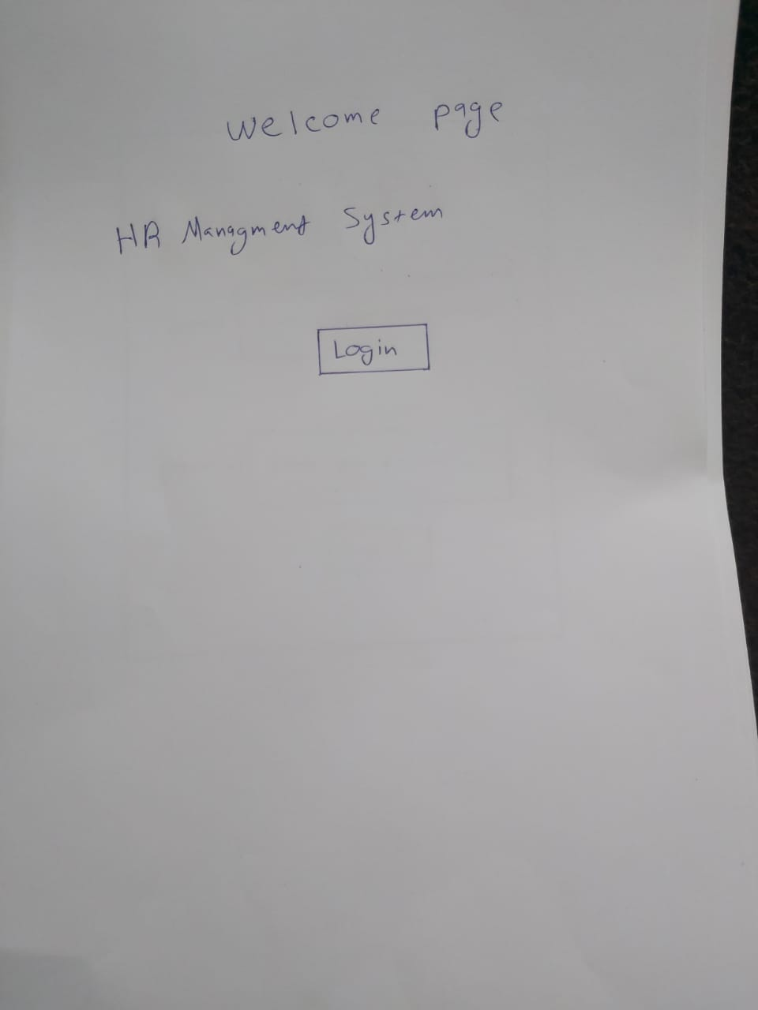

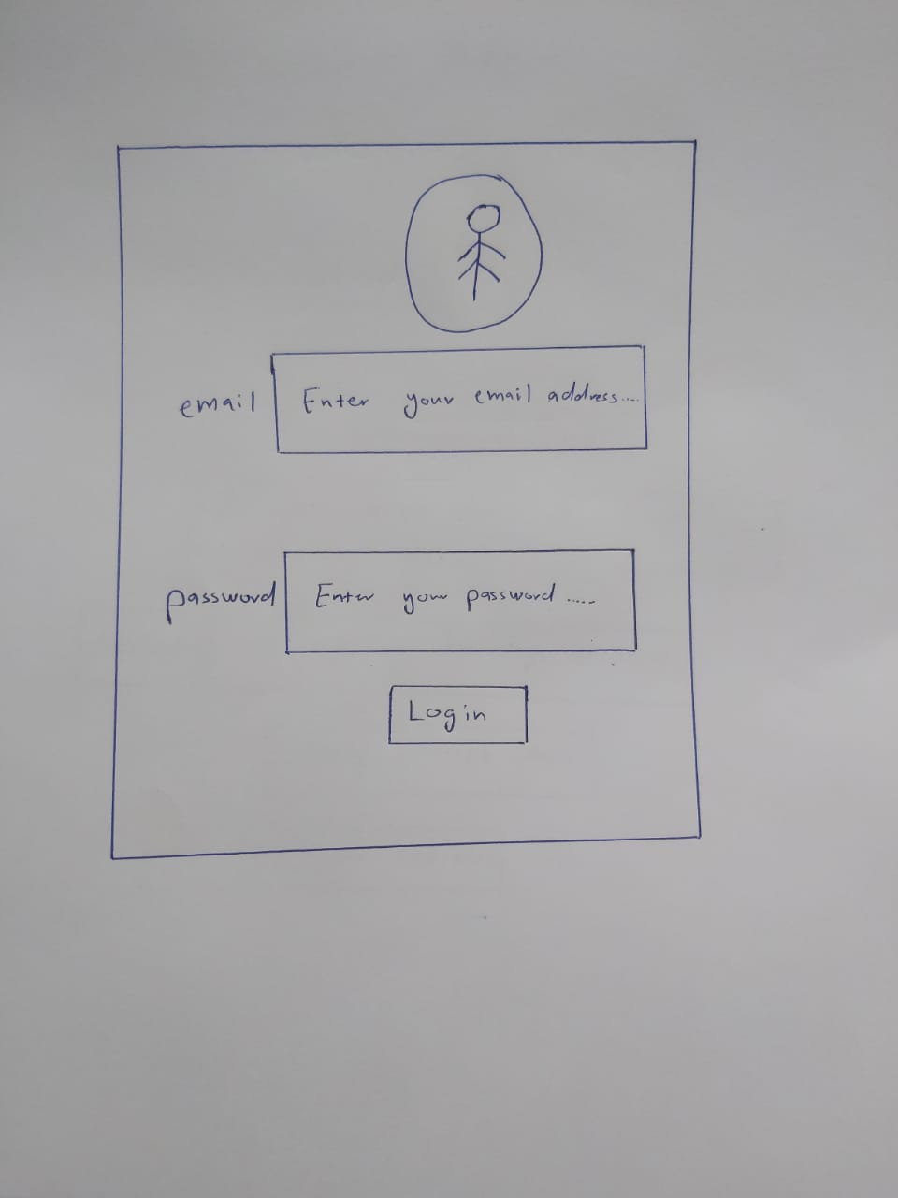

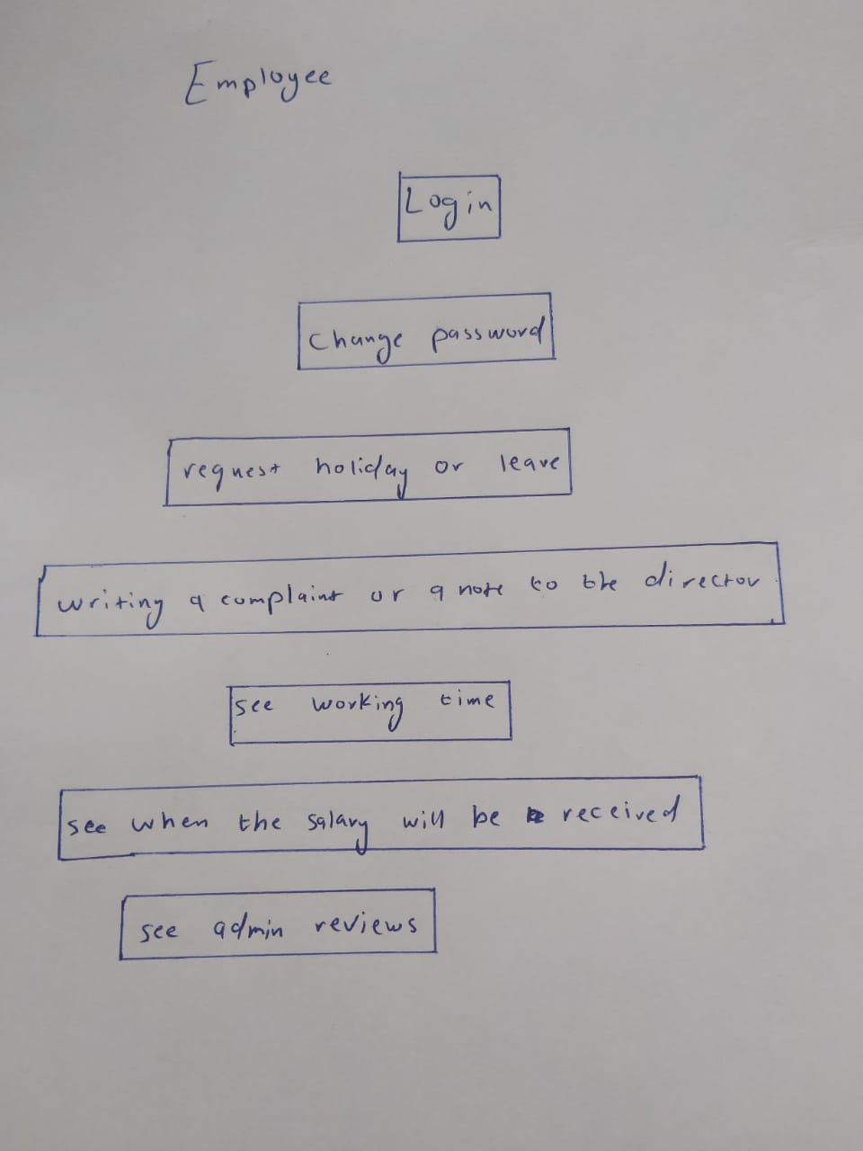

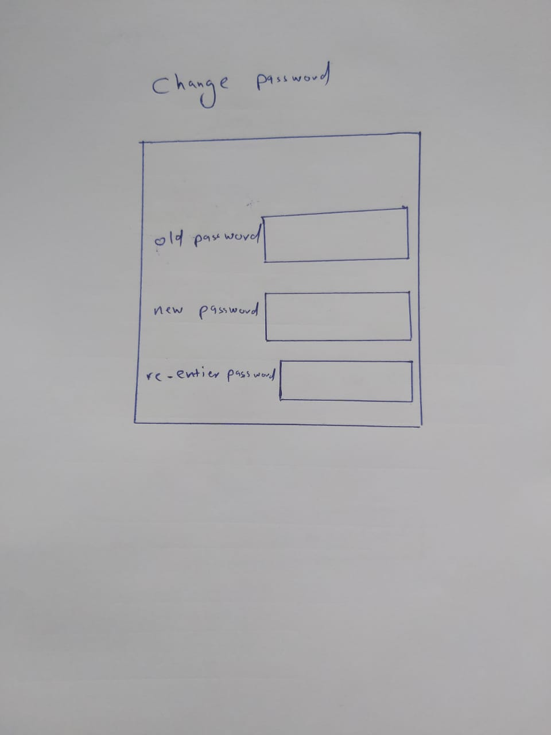

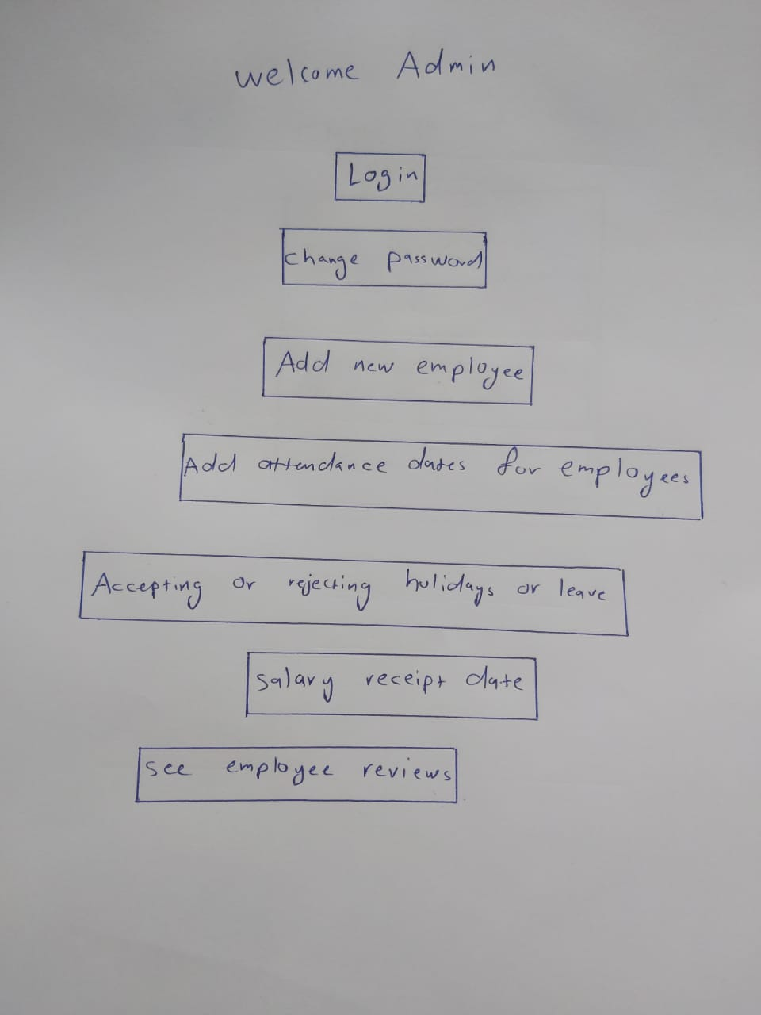

3.1.2 Hardware interface

3.1.3 Software interface

Hr management system is a website.

3.1.4 Communication interface

HR Management System is a website used to complete some simple transactions using the Internet instead of the paper-based system.